- Program Plan: Fish Eater Name: Yang Lu
Brief outline of program requirements:  What techniques/skills to be demonstrated? | Make a game with a score-keeping mechanism with at least:  - 2 objects  - Methods, behaviors  - Parameters  - Decisions, while loops  Demonstrate ability to use the features in Alice to create a solution to a problem VIA programming. Would demonstrate creativity and have logical thinking in order to program it.
What objects are you going to include in your solution? | - A shark to eat  - Fish to eat  - Text for instructions, score, etc. |  | Brief outline of your solution (describe what your program will “do”): |  | The user will be able to control a shark and swim around eating fish.
What inputs are there?  What processing is undertaken?  What outputs are there in your plan? | Input the shark and the fish, in which only the shark can eat the fish.  The process of when the fish gets too close, the shark eats the fish.  Output would be the increase in 1 point of score per fish. |  | How will you know your solution is successful?  How are you going to test the program? |  | I will know my solution is successful if I can control the shark smoothly and make sure there will always be fish to eat.  I will test my program by playing it myself first, then having my peers play the game and I will take down any suggestions.
Below is space to show your algorithmic plan of your solution. You can choose to represent your solution using a graphical or textual storyboard. In addition to this you will need to represent a part of your program where you have an If/Else or While loop with a flowcharts. You do not need to use all the space provided and may delete the unused boxes.
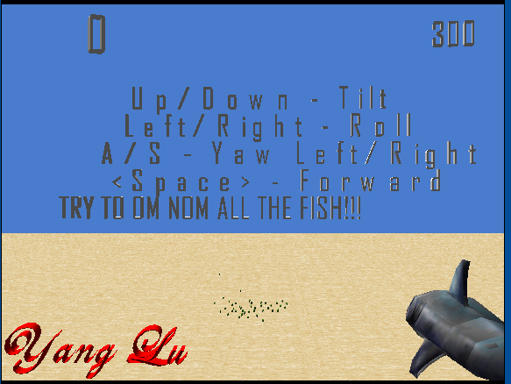 |  | 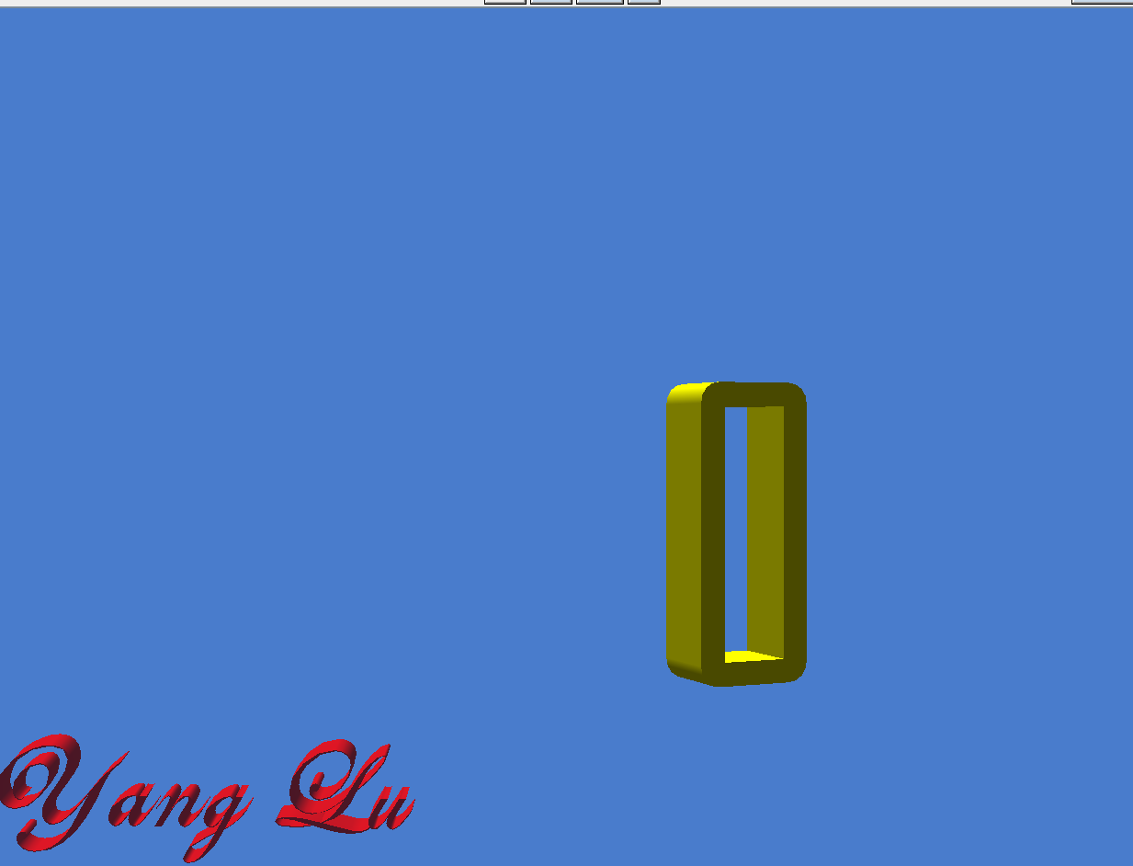 |  | 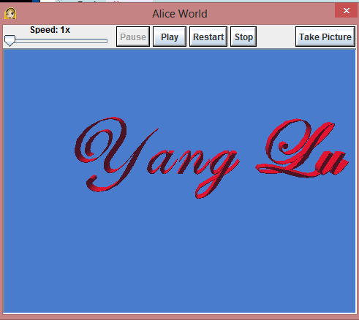
Objects used: Text, Shark, Fish  Events: Actual game events happen  Methods you have created: Shark tilt/roll/yaw, text disappear, score increase, timer decrease, fish run randomly  Important commands:  Distance above: keep fish & shark above the ground  Distance to: detect when the shark can eat the fish  While: make everything stop when the timer stops  If/Else: could not do any detection without this one |  | Objects used: Text  Events: Score flashes to indicate end of game  Methods you have created: Score flash  Important commands: |  | Objects used: Text  Events: creator’s name flashes to advertise  Methods you have created: Stand out method, basically just have it flash  Important commands:

Flowchart: Fish running
Is the distance between shark & fish more than 3

Y
N
Fish runs away

Shark eats fish and fish resets

Is the fish 5 m above the ground
Is the fish within 200m of the ground
Y
Y
Do nothing

Is the fish within 100m of the shark
Do nothing

N
N
Y
Do nothing
N
Move fish down
Move fish up

Move fish towards shark

Notes to explain flowchart:
It first see if the fish is close enough to eat
If it isn’t outside of 3m, it eats it
However, if it is outside of 3m, it continues running and checks for 3 more things: (left to right = 1-3)
- Makes sure the fish is above the ground
- Makes sure the fish isn’t too high
- Makes sure the fish can be visible from the shark’s view to make sure there is enough fish to catch
Then a while loop starts these all over again

- Implementation: (Program Code and Screenshots)

Yang Lu P2 Game's Code

Created by: Yang Lu

world

Events
When the world starts
Do:
  world.my first method

While Up is pressed
Begin:
  <None>
During:
  shark.Tilt down
End:
  <None>

While Down is pressed
Begin:
  <None>
During:
  shark.Tilt up
End:
  <None>

While Left is pressed
Begin:
  <None>
During:
  shark.Roll left
End:
  <None>

While Right is pressed
Begin:
  <None>
During:
  shark.Roll right
End:
  <None>

While Space is pressed
Begin:
  <None>
During:
  shark.Forward
End:
  <None>

While A is pressed
Begin:
  <None>
During:
  shark.Yaw left
End:
  <None>

While S is pressed
Begin:
  <None>
During:
  shark.Yaw right
End:
  <None>

When the world starts
Do:
  Timer.Countdown

When the world starts
Do:
  shark.Tail Flap

When the world starts
Do:
  shark.Ground

Methods
world.my first method ( )
No variables
Do together
// Instructions disappear
Do in order
Wait 12 seconds
Instructions set opacity to 0 (0%)
While ( world.Time > 0 )
// Actual game
Do together
world.Fish Running Fish sub = fish
world.Fish Running Fish sub = fish2
world.Fish Running Fish sub = fish3
world.Fish Running Fish sub = fish4
world.Fish Running Fish sub = fish5
world.Fish Running Fish sub = fish6
world.Fish Running Fish sub = fish7
world.Fish Running Fish sub = fish8
world.Fish Running Fish sub = fish9
world.Fish Running Fish sub = fish10
world.Fish Running Fish sub = fish11
world.Fish Running Fish sub = fish12
world.Fish Running Fish sub = fish13
world.Fish Running Fish sub = fish14
world.Fish Running Fish sub = fish15
world.Fish Running Fish sub = fish16
world.Fish Running Fish sub = fish17
world.Fish Running Fish sub = fish18
world.Fish Running Fish sub = fish19
world.Fish Running Fish sub = fish20
world.Fish Running Fish sub = fish21
world.Fish Running Fish sub = fish22
world.Fish Running Fish sub = fish23
world.Fish Running Fish sub = fish24
world.Fish Running Fish sub = fish25
world.Fish Running Fish sub = fish26
world.Fish Running Fish sub = fish27
world.Fish Running Fish sub = fish28
world.Fish Running Fish sub = fish29
world.Fish Running Fish sub = fish30
world.Fish Running Fish sub = fish31
world.Fish Running Fish sub = fish32
world.Fish Running Fish sub = fish33
world.Fish Running Fish sub = fish34
world.Fish Running Fish sub = fish35
world.Fish Running Fish sub = fish36
world.Fish Running Fish sub = fish37
world.Fish Running Fish sub = fish38
world.Fish Running Fish sub = fish39
world.Fish Running Fish sub = fish40
world.Fish Running Fish sub = fish41
world.Fish Running Fish sub = fish42
// End game sequence
camera set vehicle to world
Do together
camera move up 1000 meters duration = 0.25 seconds
Timer set opacity to 0 (0%)
world set fogStyle to distance
world set fogFarDistance to 10 meters
Do together
ScoreBoard move down 0.05 meters
ScoreBoard move left 0.05 meters
ScoreBoard resize 4
// Show off the score
ScoreBoard.Flash
// Advertise the creator
Yang Lu.Stand out

world.Fish Running ( [Obj] Fish sub)
No variables
If ( ( shark distance to Fish sub ) > 3 )
// Fish running away randomly
Do together
Fish sub turn left ( random number minimum = -1 maximum = 1 ) style = abruptly
Fish sub turn forward ( random number minimum = -1 maximum = 1 ) style = abruptly
Fish sub roll left ( random number minimum = -1 maximum = 1 ) style = abruptly
Fish sub move forward 5 meters style = abruptly
// Above ground
If ( ( Fish sub distance above ground ) < 5 )
Fish sub move up 5 meters asSeenBy = ground
Else
Do Nothing
// Not too far above ground
If ( ( Fish sub distance above ground ) > 200 )
Fish sub move up 5 meters asSeenBy = ground
Else
Do Nothing
// Fish stay within range of the shark
If ( ( Fish sub distance to shark ) > 100 )
Fish sub turn to face shark duration = 0 seconds
Fish sub move forward 10 meters duration = 0 seconds
Else
Do Nothing
Else
// Fish gets eaten
Do together
shark.OM NOM
Fish sub set opacity to 0 (0%) duration = 0 seconds
// Fish resets 50m away to ensure there are always fish in the field
Fish sub move forward 50 meters duration = 0 seconds
Fish sub set opacity to 1 (100%) duration = 0 seconds
world.Keep Score Fish Eaten = Fish sub

world.Keep Score ( [Obj] Fish Eaten)
No variables
// How score is added when fish gets eaten
For all world.Fish ate , one item_from_Fish ate at a time
If ( Fish Eaten == item_from_Fish ate )
increment world.Score by 1
ScoreBoard set text to ( world.Score as a string )
Else
Do Nothing

shark

Methods
shark.Roll left ( )
No variables
shark roll left 0.1 revolutions duration = 0.25 seconds style = abruptly

shark.Roll right ( )
No variables
shark roll right 0.1 revolutions duration = 0.25 seconds style = abruptly

shark.Tilt up ( )
No variables
shark turn backward 0.05 revolutions duration = 0.25 seconds style = abruptly

shark.Tilt down ( )
No variables
shark turn forward 0.05 revolutions duration = 0.25 seconds style = abruptly

shark.Forward ( )
No variables
shark move forward 10 meters style = abruptly

shark.Tail Flap ( )
No variables
shark.body.tail turn right 0.07 revolutions style = end gently duration = 0.3 seconds
While ( world.Time > 0 )
shark.body.tail turn left 0.14 revolutions style = end gently duration = 0.3 seconds
shark.body.tail turn right 0.14 revolutions style = end gently duration = 0.3 seconds

shark.OM NOM ( )
No variables
// OM NOM--means-- eat
Do together
shark.jaw turn forward 0.14 revolutions duration = 0.25 seconds
shark move forward 3 meters duration = 0.25 seconds
shark.jaw turn backward 0.14 revolutions duration = 0.25 seconds

shark.Yaw left ( )
No variables
shark turn left 0.05 revolutions style = abruptly duration = 0.25 seconds

shark.Yaw right ( )
No variables
shark turn right 0.05 revolutions style = abruptly duration = 0.25 seconds

shark.Ground ( )
No variables
// Shark stays above ground
While ( world.Time > 0 )
If ( ( shark distance above ground ) < 2 )
Do together
shark turn backward 0.05 revolutions
shark move up 10 meters
Else
Do Nothing

ScoreBoard

Methods
ScoreBoard.Flash ( )
No variables
ScoreBoard set color to (0, 0, 0) duration = 0.5 seconds
ScoreBoard set color to (1, 0, 0) duration = 0.5 seconds
ScoreBoard set color to (0, 1, 0) duration = 0.5 seconds
ScoreBoard set color to (0, 0, 1) duration = 0.5 seconds
ScoreBoard set color to (1, 1, 0) duration = 0.5 seconds
ScoreBoard set color to (0.502, 0, 0.502) duration = 0.5 seconds
ScoreBoard set color to (1, 0.647, 0) duration = 0.5 seconds
ScoreBoard set color to (1, 0.686, 0.686) duration = 0.5 seconds
ScoreBoard set color to (0.635, 0.165, 0.165) duration = 0.5 seconds
ScoreBoard set color to (0, 1, 1) duration = 0.5 seconds
ScoreBoard set color to (1, 0, 1) duration = 0.5 seconds
ScoreBoard set opacity to 0 (0%) duration = 3 seconds

Timer

Methods
Timer.Countdown ( )
No variables
// Timer coutndown, 300 times for 300 seconds
Loop 300 times times
decrement world.Time by 1 duration = 0 seconds
Timer set text to ( world.Time as a string )

Yang Lu

Methods
Yang Lu.Stand out ( )
No variables
Do together
Yang Lu move left 0.66 meters
Yang Lu move up 0.66 meters
Yang Lu resize 2
Loop infinity times times
Yang Lu set color to (1, 0, 0) duration = 0.25 seconds
Yang Lu set color to (0, 1, 0) duration = 0.25 seconds
Yang Lu set color to (1, 0.686, 0.686) duration = 0.25 seconds
Yang Lu set color to (0, 0, 1) duration = 0.25 seconds
Yang Lu set color to (1, 1, 0) duration = 0.25 seconds
Yang Lu set color to (0.502, 0, 0.502) duration = 0.25 seconds
Yang Lu set color to (1, 0.647, 0) duration = 0.25 seconds
Yang Lu set color to (0, 1, 1) duration = 0.25 seconds
Yang Lu set color to (1, 0, 1) duration = 0.25 seconds

- Review of Plan and Program

Brief outline of program requirements: | Make a game with a score-keeping mechanism with at least:  - 2 objects  - Methods, behaviors  - Parameters  - Decisions, while loops | Brief outline of planned solution: | Shark goes around eating fish, shark will have moving methods, fish will be running away from the shark.  Will be a score board and a timer, player gets 5mins to eat as much fish as possible.  Shark will be able to roll and tilt
Brief outline of actual program: | Shark goes around eating fish. Fish will be randomly moving around to increase difficulty.  There is a scoreboard and a timer. 5 minutes.  Added “Yang Lu” at the bottom of the screen to advertise the creator (me!)  End game sequence where the score gets big and flashes for a bit, then the creator’s (me!) name flashes forever.  Shark can roll and tilt and yaw controls.
Did the actual program differ from the planned program?  How did the program change as you began programming it?  Explain how and why.  What objects and actions were different? How did the plan help the solution? | The actual program did differ from the planned program.  - The fish running straight away from the shark became fish running away randomly. Though it is less realistic, the game would be no challenge if the fish ran away in a straight line.  - Shark can have yaw control instead of just roll and tilt.  - As I neared completion I got to thinking about additional features that other games have. As a result, I added an end game screen and added advertisements (my name) to the game.  - Instructions didn’t disappear before so people can go back to it and refer to it. However, I realized the controls are pretty simple, and made it disappear.  - The plan helped my final solution as it did set out the base for my solution. It kept me on track and made sure my final solution is one that will meet the requirements of the problem.
What were the strengths of the solution? | - The shark has all levels of control, except backwards, since it would be unrealistic. There is roll control, tilt control, and yaw control.  - The fish would move around randomly, giving the user a challenge to react fast enough to follow the twist and turns of the fish.  - The fish and the shark are unable to go into the ground.  - The fish cannot stray too far from the shark, making sure the user will have fish in view when he/she turns.  - Interesting end game sequence.  - $$$ advertises the creator for more profit in future games made $$$  - Easy to add more features. Everything is laid out plainly and has
What were the weaknesses of the solution? | If the user forces the shark to tilt down and move down. After awhile, it is possible to force through the ground. However, in normal play where the user would not do so, the game would be fine.
Testing for failure – how did you check your program and what testing did you? Testing: Matching criteria of success with outcomes. Outline any changes you made to your solution and why. | I played my game and had my peers play the game as well to receive feedback and take down suggestions:  I realized that it was too easy since fish moved straight away from you. Just point and hold down go forward and it would be easy to get a high score.  I made the fish move randomly  Corey said: the game is too hard to control since you can’t just make small adjustments to yaw left and right. Instead, you had to roll a full quarter and tilt up a little.  I added yaw controls to the shark  Omar said: It’s too hard to catch the fish for people who haven’t flew planes in video games since this degree of control is unfamiliar to them  I increased the number of fish from 25 to 42
Teamwork:  Did you work in a group? If so, outline how the group divided up the tasks and what areas you were responsible for. | No group for actual game programming. However, suggestions from my friends really helped the game takes its shape:  Feedback that made some major changes to the game:  Omar and Corey
General Comment: | This was a really fun project to do. It was challenging as it requires us to work around the features of Alice to get what we want. Also, it contains a good reward of having my very own game to play!  Mr. Blakey, I had a great time in C.S. 101!  See you next week in C.S. 201!!!

